**Assignment**

**Single Online Reminder**

**Mobile Application**

Contents

Introduction 3

Creation of the Ionic App 4

Submission of the Ionic App 4

App Structure 5

Technical Details 5

Application description and screenshots 6

Application in action 8

### **Introduction**

You are required to write an Ionic mobile application, that allows a user to enter a single Reminder on his/her mobile device and store the Reminder on the [JSON Blob](https://jsonblob.com/) website.

The Reminder shouldn’t be stored on the user’s mobile device – only the JSONBlob reference to the reminder should be stored in localStorage.

The Reminder should consist of the following information:

* Title
* Description
* Priority
  + High
  + Medium
  + Low
* Complete
  + True
  + False

In addition, two extra fields for the Reminder should be created on the JSONblob.com website, but should not be visible in the app:

* Creation Date (Date of Reminder Creation)
* Creation Time (Time of Reminder Creation)

The application should allow the user to store only one Reminder at a time. So if he/she creates one reminder, this reminder must be deleted before a new one can be stored. However, any field of the Reminder can be updated (except Creation Date and Creation Time).

If a Reminder has been created and the user exits the application and restarts it, then the reminder should be displayed.

### **Creation of the Ionic App**

The application should be created as follows:

* ionic start GXXXXXXX blank

Where GXXXXXXX is your student number.

### **Submission of the Ionic App**

The zipped Ionic application should be uploaded to the *Semester 2 Repeat Project* section of Moodle no later than **Tuesday August 29th 2017 at 9:00am**.

### **App Structure**

The application should consist of an index.html file where the body consists only of the following:

<body ng-app="myNews">

<ion-nav-view></ion-nav-view>

</body>

There should be one template file which displays the Reminder if one exists, or if not displays an option to create a Reminder.

### **Technical Details**

There should be one State representing the Reminder View.

Sending data to and receiving data from the [https://jsonblob.com](https://jsonblob.com/) website should be performed in a Service.

The JSON Blob [API](https://jsonblob.com/api) has four main endpoints:

* [POST](https://jsonblob.com/api#post) – This should be used to create the Reminder
* [GET](https://jsonblob.com/api#get) – This should be used to get an existing Reminder
* [PUT](https://jsonblob.com/api#put) – This should be used to update an existing Reminder
* [DELETE](https://jsonblob.com/api#delete) – This should be used to delete an existing Reminder

A final requirement is that when a Reminder has been successfully created on the jsonblob.com website, the console should show the Blob ID of the Reminder as shown. This Blob ID should be stored in localStorage.

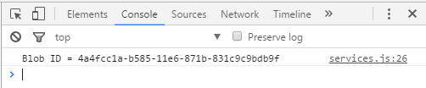

Figure 1 Console showing JSON Blob ID

**NOTE:** Nothing else (no debug messages etc.) should be printed on the console.

### **Application description and screenshots**

The application should display the following fields/data on startup if there is no existing Reminder:

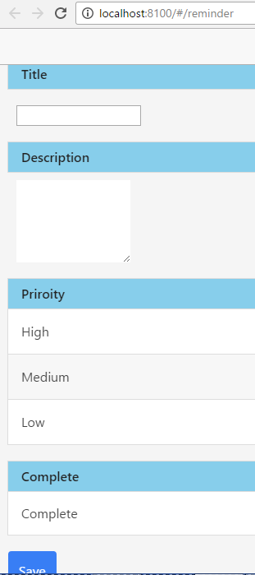

Figure 2 Application with no existing Reminder

The user then enters details of a Reminder he/she wishes to store.

The two Reminder fields:

* Creation Date
* Creation Time

are calculated by the application, and never visible to the user in the app, but are stored on JSON.com.

These fields are only updated when a Reminder is created (saved), not when a Reminder is updated.

If the data is stored successfully on jsonblob.com, the *Save* button is no longer shown, but instead *Update* and *Delete* buttons are displayed.

The title of the page is automatically set to the title of the Reminder.

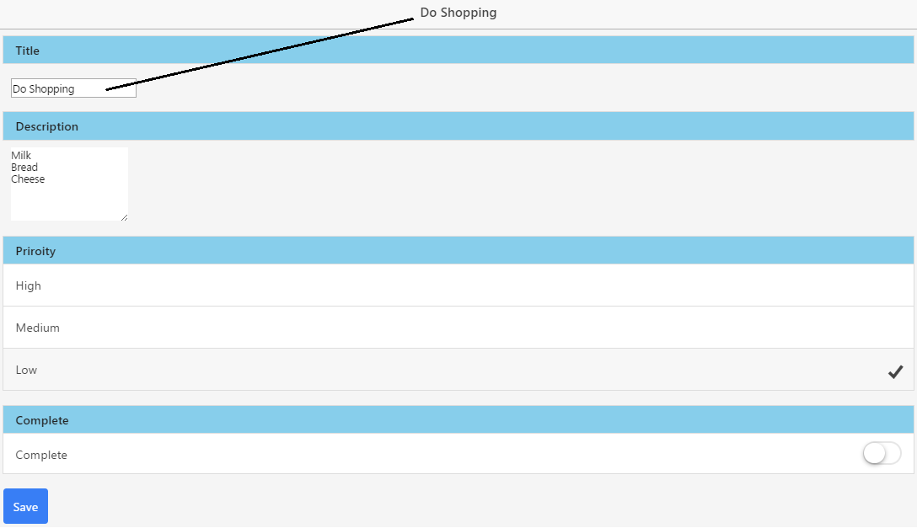

Figure 3 Creating a New Reminder

As described previously, when a Reminder is successfully created the JSON blob ID should be displayed in the console:

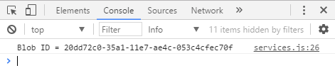

Figure 4Console showing JSON Blob ID

*Reminder as stored on jsonblob.com.*

Note *creationDate* and *creationTime* are stored on jsonblob.com, but not shown in the app. 

Figure 5 Reminder on jsonblob.com

If the application is closed and re-opened and a Reminder has been previously created but not deleted, this Reminder should be shown.

When a Reminder is deleted, the *Update* and *Delete* buttons are no longer shown, but instead *Save* button is displayed.

The Reminder should no longer be accessible on the jsonblob.com website.

### **Application in action**

Download *Demonstration of App Dev Repeat Project.webm*from the *Semester 2 Repeat Project*section of Moodle and open it in a web browser to see a working version of how the finished assignment should look.